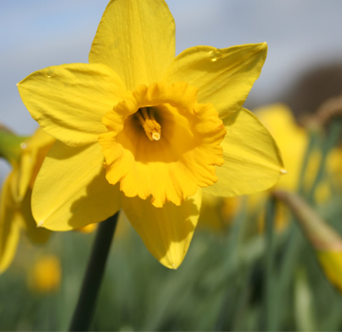
Garthdee Community council

Garthdee Community Council
Address. C/O Inchgarth community centre
Aboyne Place, Garthdee AB10 7DR
garthdeecc@gmail.com
Paul O’ Connor MBE Chairman
07889666726

AGENDA
Meeting 9th May 2017 7pm@inchgarth community centre.

- Attendance and welcome.
- Apologies.
- Police report.
- Minutes of the previous meeting.
- Matters arising.
- Correspondence.
- Daniel Laird First bus.
- Parking issues in Garthdee.
- The Garthdee walkabout. Discuss and choose date. August?
- Monthly accounts and account signatories update.
- Old Rs McColls unit.
- Planning officer’s report. Student accommodation behind RGU, Caledon Bar, Suttie development. Community council boundaries.
- Councillor’s reports.
- AOCB
- Date and time of the next meeting.

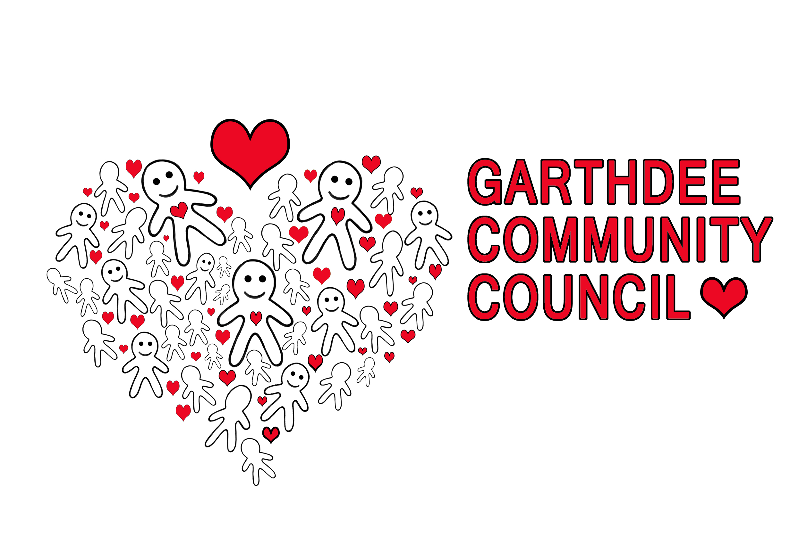
Logo by Natalie Raeburn
Kaimhill Primary school

