Garthdee Community council
AGENDA
Meeting 14th November 2017
7pm@inchgarth community centre.

- Attendance and welcome.
- Apologies.
- Police report.
- Minutes of the previous meeting.
- Matters arising.
- Correspondence.
- By election and promotion update.
- Proposed Garthdee cycle path.
- Kaimhill primary school update. 1 Young defenders. 2 Head teacher position. 3 Christmas fayre 30th Nov 5.30pm. – donation

- Garthdee Parish church- how can the entire community work together to assist. Hilda Smith.
- Community open day 18th December 5-7pm- an update

- New community website update. www.garthdee.info Twitter account @garthdeecc Facebook Garthdeecc Garthdee com council website.
- Business cards for all community council members.
- The way ahead. Ideas for future meetings. Guest speakers, what do we want to get out of the community council. How do we engage?
- Monthly accounts Andrew Murray
- Planning officer’s report. Irene Buchan
- Councillor’s reports.
- AOCB
- Date and time of the next meeting.
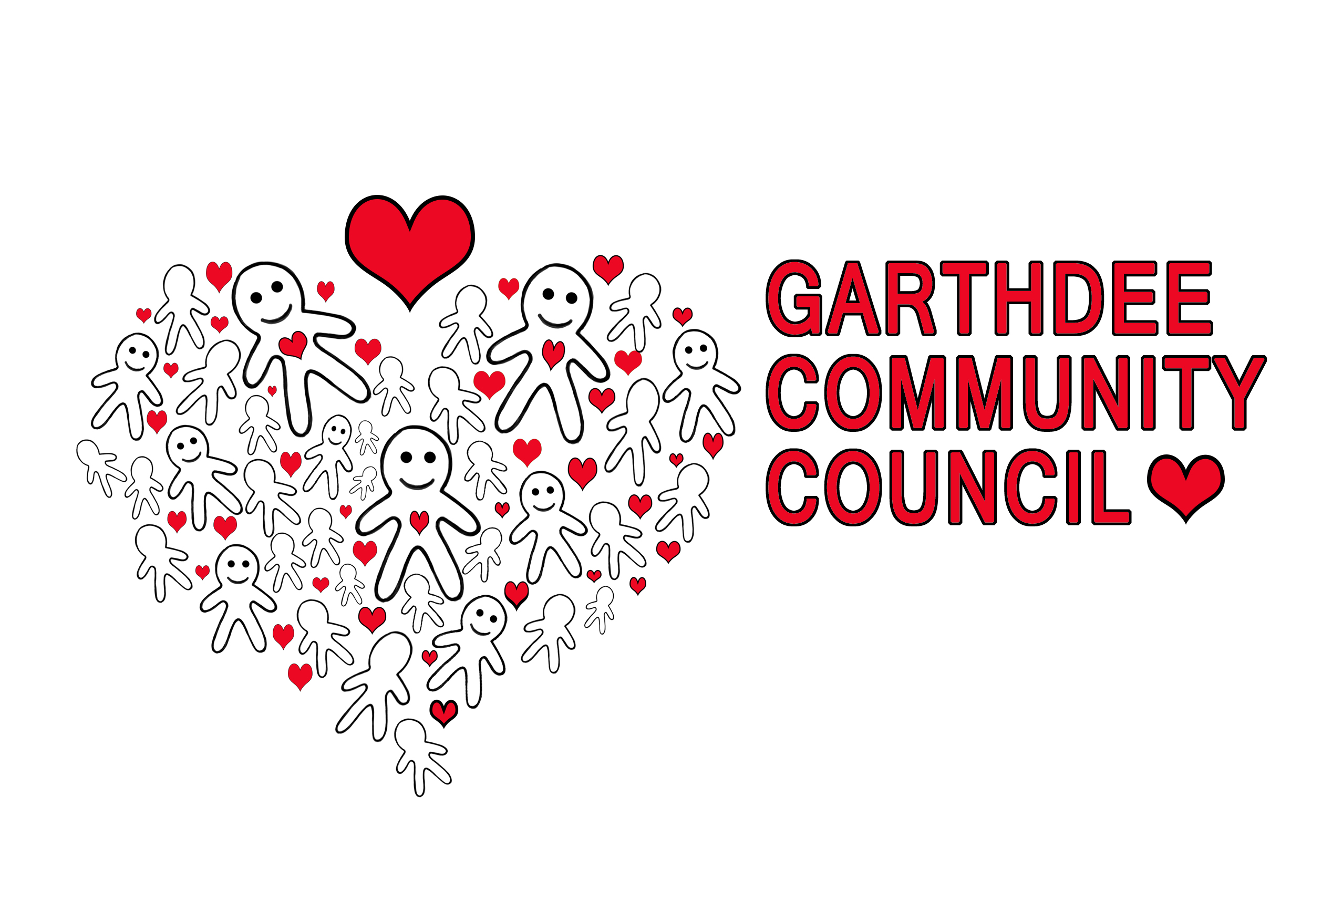
Logo by Natalie Raeburn
Kaimhill Primary school

