Garthdee Community council
AGENDA
Meeting 11th September 2018
7pm@inchgarth community centre.
- Attendance.
- Introductions and Apologies.
- Police report.
- Minutes of the previous meeting.
- Matters arising.
- Correspondence.
- Donations Discussion and proposals
- Garthdee Parish church Follow up from the public meeting
- Community council elections October Discussion on who is standing, nomination forms.
- Community round up Inchgarth. Harlaw. Pensioners complexes. Bus stop. Parent council.
New Rgu principal. Parking.

- Monthly accounts Andrew Murray
- Planning officer’s report.

- Councillor’s reports.
- AOCB
- Date and time of the next meeting.
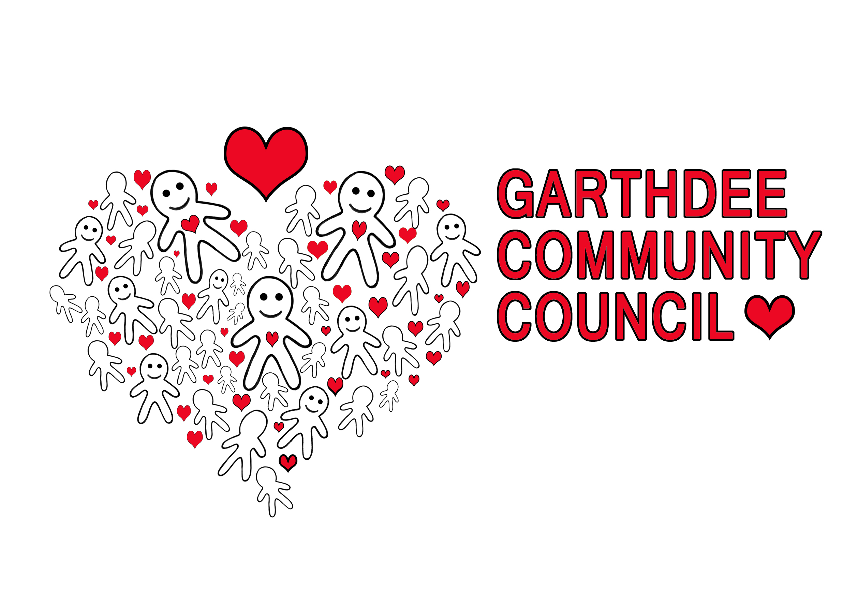Logo by Natalie Raeburn Kaimhill Primary school

