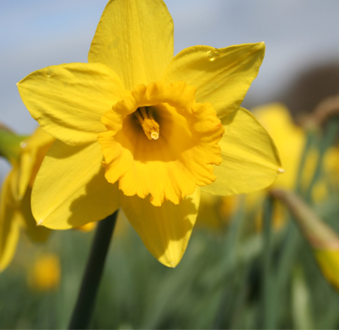
Garthdee Community council

Garthdee Community Council
Address. C/O Inchgarth community centre
Aboyne Place, Garthdee AB10 7DR
garthdeecc@gmail.com
07889666726

AGENDA
Meeting 11TH April 2017 7pm@inchgarth community centre.

- Attendance and welcome.
- Apologies.
- Co-option of Paul O’ Connor onto community council. Nomination of Andrew Murray as associate member representing Inchgarth or Garthdee liaison group.
- Nominations for chair of the community council.
- The future of the community council and by-election late 2017.
- Minutes of the previous meeting.
- Matters arising.
- Correspondence.
- Monthly accounts and annual accounts.
- Bus stop within RGU- Request first bus to attend next meeting. Bus stop Craigievar Road causing tailbacks.
- Student flats behind RGU, development at Caledon, Suttie and Ferrari development on Inchgarth Road.
- Police report.
- Councillor’s reports.
- Planning officer’s report.
- Potential guests for future meetings.
- Website, newsletter, email address, social media.
- AOCB
- Date and time of the next meeting.

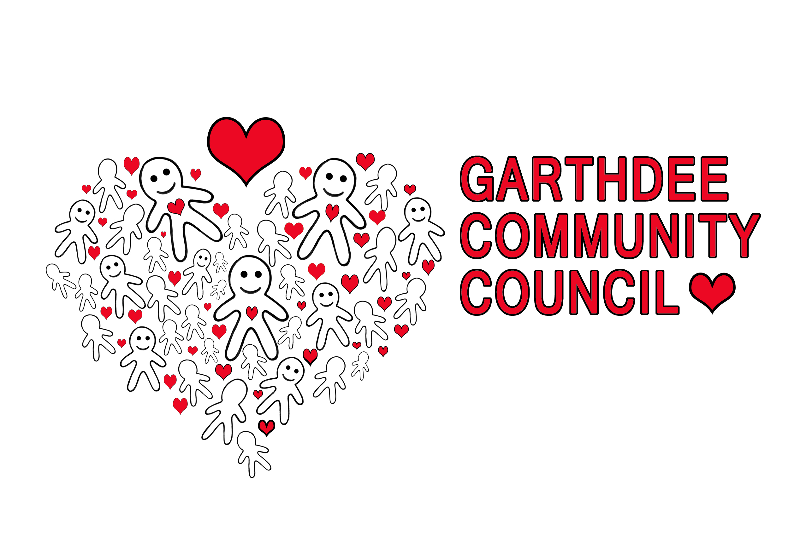
Logo by Natalie Raeburn
Kaimhill Primary school

